

| Phone Museum | |
| --- | --- |
| App | |
| Control Report | |
| **Control Date** | 19th of November 2024 |
| **Academic year** | 2024/2025 |
| **Teaching Staff** | João Varajão |
| **Degree** | Master's in Telecommunications and Computer Engineering |
| **Year** | 2nd Year |
| **Curricular Unit** | Gestão de Projetos de Tecnologias de Informação |



The Team

|  | **Catarina da Cunha Malheiro da Silva Pereira**  PG53733  [pg53733@alunos.uminho.pt](mailto:pg53733@alunos.uminho.pt)  Braga, Portugal |
| --- | --- |
|  | **Inês Cabral Neves**  PG53864  [pg53864@alunos.uminho.pt](mailto:pg53864@alunos.uminho.pt)  Porto, Portugal |
|  | **Leonardo Dias Martins**  PG53996  [pg53996@alunos.uminho.pt](mailto:pg53996@alunos.uminho.pt)  Aveiro, Portugal |
|  | **Rodrigo Rocha del Castillo**  E12165  [e12165@alunos.uminho.pt](mailto:e12165@alunos.uminho.pt)  Santander, Spain |





| table of contents | **The Team 03 _________________________________ 01** |
| --- | --- |
| **Table of Contents _____________________________ 02** |
| **List of Tables ________________________________ 04** |
| **List of Figures & Graph_________________________ 05** |
| 1. **Executive Summary _____________________06** |
| 1. **Scope ________________________________07**    1. **Project Information _____________07**    2. **Stakeholders __________________07**    3. **Restrictions in Scope ____________07** |
| **3. Timelines _____________________________ 08**   * 1. **Tracking Gant _________________ 08**   2. **Project Overview _______________ 08**   3. **Milestones Deliverables _________ 09** |
| **4. Project Costs _________________________ 10**   * 1. **Cost Overview _________________ 10**   2. **Resource Cost Overview _________ 10**   3. **Resource Overview _____________ 12**   4. **Task Cost Overview ____________ 13** |
| **5. Project Overview ______________________ 15** |
|  | **6. Risks _______________________________ 16** |
|  | **7. Success _____________________________ 17** |
|  | **8. Lessons Learned ______________________ 18** |
| **_** | **Declaration of Knowledge ______________________ 19** |



| **Table 1: Report on Project Milestones. ________ 10** | Table of Tables |
| --- | --- |
| **Table 2: Cost Details. _______________________ 12** |
| **Table 3:Project Overview. ___________________ 15** |
| **Table 4: Project Risks. ______________________ 16** |
|  |  |



| Table of Figures & Graphs | **Figure 1: Gantt Diagram. __________________ 08** |
| --- | --- |
| **Figure 2: Milestones. ______________________ 09** |
| **Graph 1: Percentage description of the project. 09** |
| **Graph 2: Project Cost State. ________________ 11** |
| **Graph 3: Cost State. _______________________ 12** |
| **Graph 4: Cost Distribution. _________________ 12** |
| **Graph 5: Resource Statistics. _______________ 13** |
| **Graph 6: Labour Status. ___________________ 13** |
| **Graph 7: Cost Study _______________________ 14** |
| **Graph 8: Cost Distribution _________________ 14** |
|  |
|  |
|  |
|  |

1. Executive Summary

The main purpose of this document is to present the project's progress up to November 16, 2024, making it possible to evaluate it and draw conclusions in terms of scope, time and cost, and it is crucial for conveying and updating the project's stakeholders on its performance. The project's main risks, their impacts and respective mitigating actions will also be listed.

At the scope level, general information about the project will be presented first, as well as the project's stakeholders. Lastly, this section will highlight the changes that have taken place over time, as well as existing rectifications.

Finally, with regard to the cost, the current project budget will be shown, taking into account the various types of costs.

The project, aimed at developing an interactive museum application, has achieved 65% completion as of November 16, 2024. Its primary goal is to enhance visitor experiences with a themed game, following a scope rectification.

Progress is on track, with milestones and deliverables aligned with the schedule, though a slight budget overrun of €148.75 has been noted. The total budget stands at €6007.75, with €3893.53 spent. Both the Cost Performance Index (CPI) and Schedule Performance Index (SPI) are favorable at 1.00 and 1.04, respectively, reflecting efficient management.

Risks such as delays, budget overruns, and loss of team members have been identified and mitigated through effective communication, monitoring, and organization. The project remains well-positioned to meet its final delivery and presentation deadlines by December 12, 2024, with success factors and lessons learned to be evaluated post-completion.

1. Scope
   1. **Project Information**

The aim of this project is to develop an application that will enrich the museum visitor's experience, offering a more interactive and personalized visit. To achieve this, it is essential to obtain feedback from visitors, which will allow the museum to better adapt to their preferences and needs.

The project has a start date of September 19, 2024 and an end date of December 12, 2024.

* 1. **Stakeholders**

The stakeholders were identified and are represented:

* **ETI students:** Directly involved and interested in the development of the project.
* **Client:** The entity that commissions the project, sets requirements, provides feedback, and ensures the final product meets their needs.
* **METI direction:** Responsible for supervising the project with the course objectives.
* **GPTI professor:** Actively involved in project management.
* **University of Minho (UM):** The institution that hosts and approves the project.
* **General public:** The users of the application and museum
* **DSI of UM:** Provision of space for the project involved in coordinating and providing technical and administrative support.
* **GPTI Group:** Catarina Pereira, Inês Neves, Leonardo Martins and Rodrigo Rocha.
  1. **Rectifications in Scope**

The application's functional requirements have been revised, and the team will now focus exclusively on developing one themed game. This game will serve as a feature of the application, designed to engage users in an interactive and experience aligned with the museum's themes and objectives.

1. Timelines
   1. **Tracking Gantt**

Figure 1 presents the partial Gantt Chart for the project, reflecting its progress up to the document submission date, November 16, 2024.

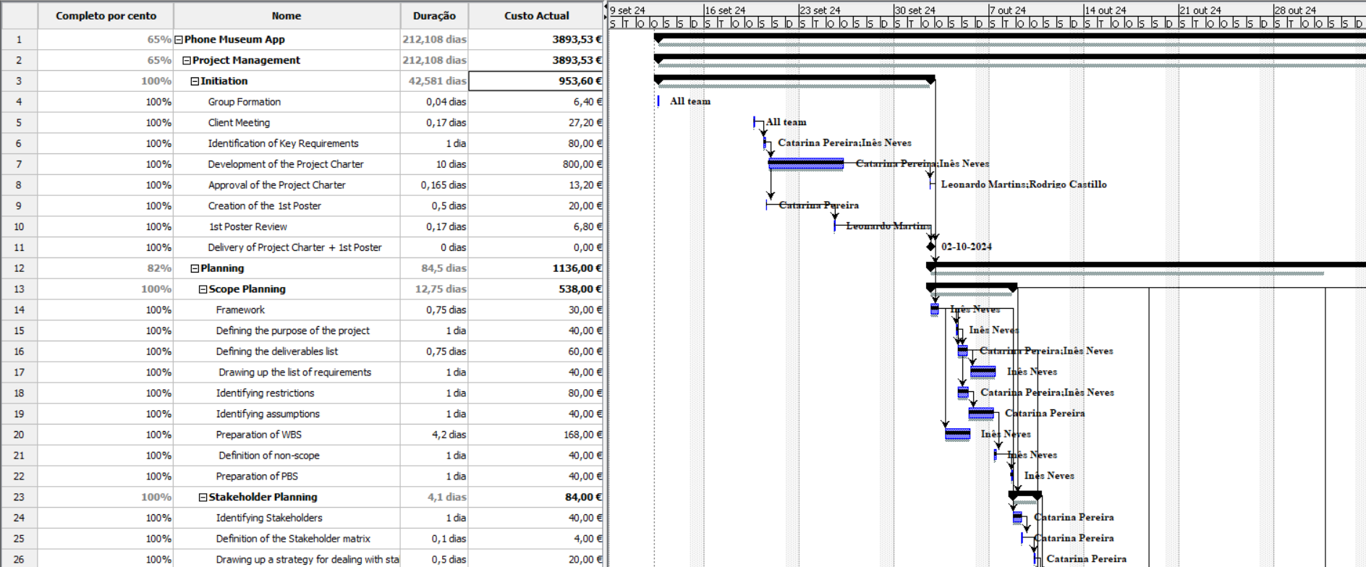

Figure 1: Gantt Diagram.

* 1. **Project Overview**

Graph 1 illustrates the current status of the project, highlighting the percentage of completion across its various phases. As of now, the project is 65% complete.

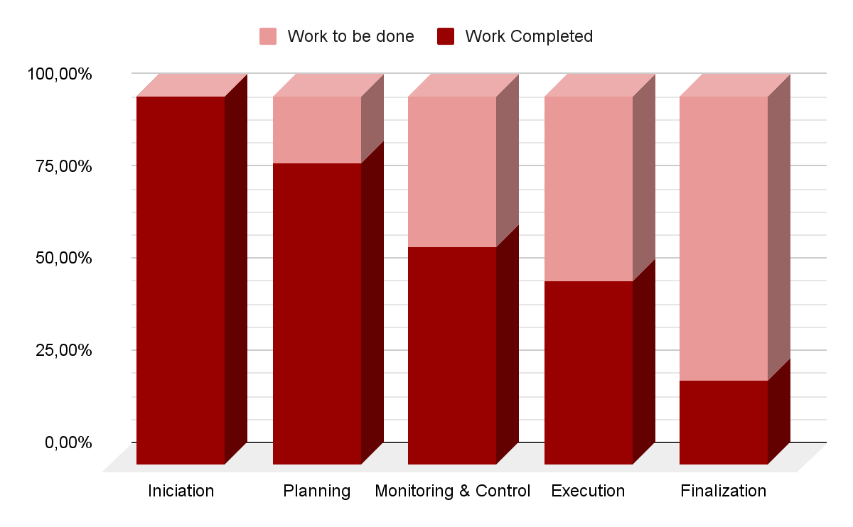

Graph 1: Percentage description of the project.

* 1. **Milestones e Deliverables**

Figure 2 outlines all the milestones the team has committed to achieving, including internal milestones (related to course deliverables) and external milestones (associated with the client’s project requirements).

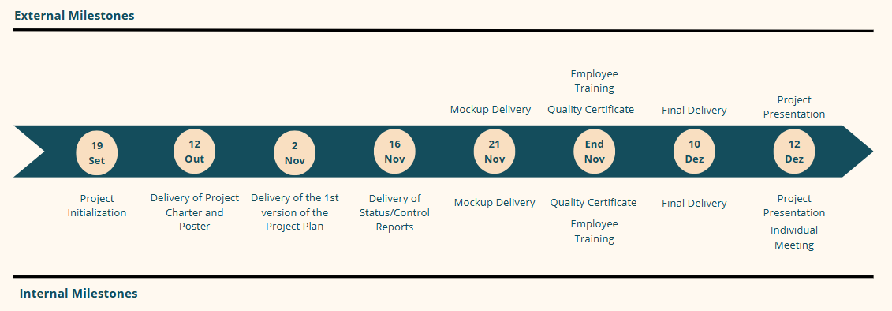

| Figure 2: Milestones. |
| --- |

As shown in Table 1, there are no overdue tasks. It also highlights the milestones that have been completed, along with those scheduled for the future.

| Table 1: Report on project milestones. | | | | | | | |
| --- | --- | --- | --- | --- | --- | --- | --- |
| **Late Milestones** | |  | **Next Milestones** | |  | **Completed Milestones** | |
|  |  |  |  |  |  |
| *Name* | *Conclusion* | *Name* | *Conclusion* | *Name* | *Conclusion* |
|  |  | Delivery of Status/ Control Reports | 16 Nov | Delivery of Project Charter and Poster | 12 Out |
|  |  | Mockup Delivery | 21 Nov | Delivery of the 1st Version of the Project Plan | 2 Nov |
|  |  | Employee Training | End Nov |  |  |
|  |  | Quality Certificate | End Nov |  |  |
|  |  | Final Delivery | 10 Dec |  |  |
|  |  | Project Presentation | 12 Dec |  |  |

1. Project Costs
2. **Cost Overview**

Graph 2 displays the project's costs, including both actual and remaining expenses. The data reveals that the project has exceeded the budget by €148,75, which accounts for 3,72% of the current cost and 2,48% of the total budget.

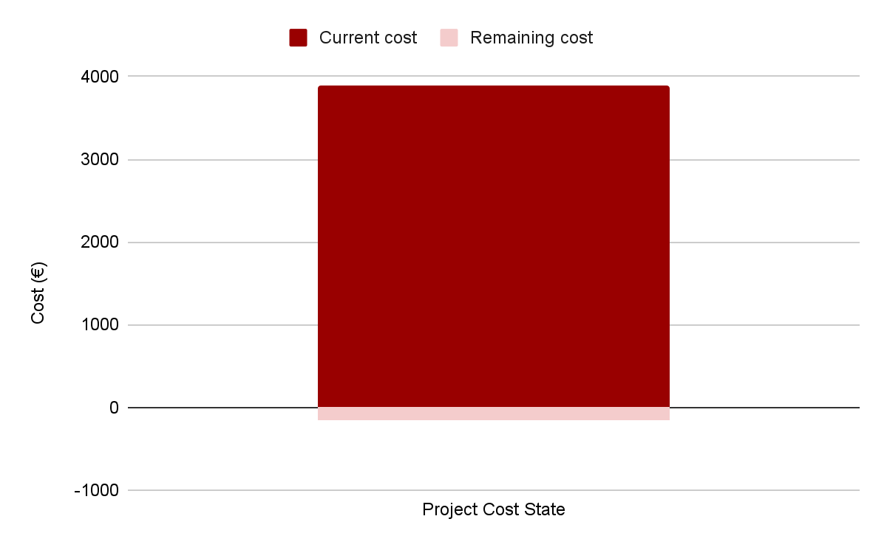

Graph 2: Project Cost State.

1. **Resource Cost Overview**

The general cost distribution of resources, as shown in Graph 4, breaks down costs by resource type (labor or material), including actual, remaining, and base plan costs for each team member. Additional details on actual labor, costs, and standard rates are provided in Graph 3 and Table 2. Notably, the majority of the costs (€2291,17) are attributed to human resources, while material resources (such as computers and travel expenses) account for €1602,36, as illustrated in Graph 4.

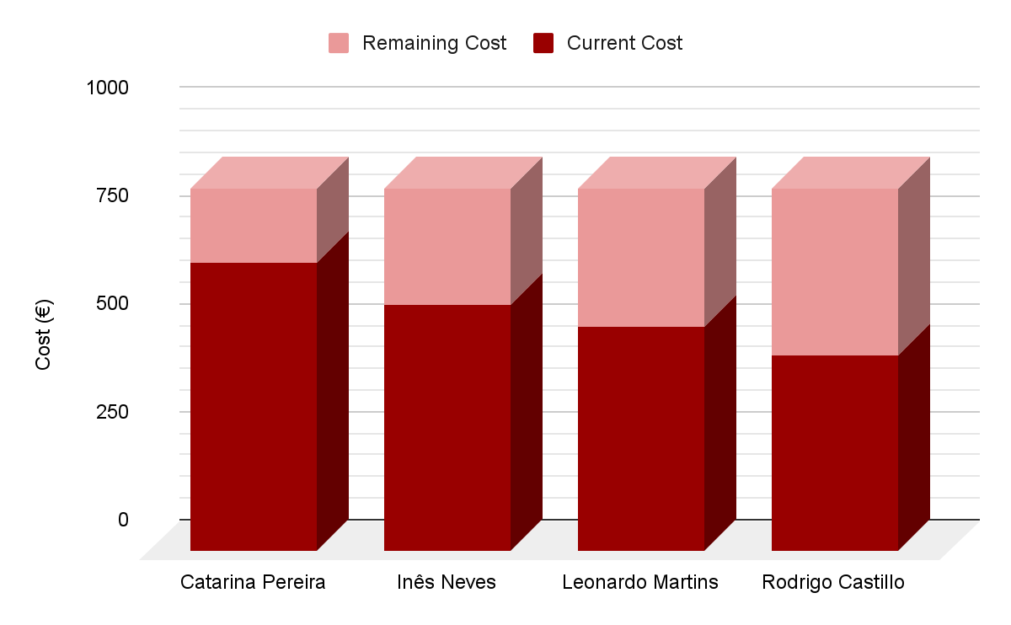

Graph 3: Cost State.

| Table 2: Cost Details. | | | |
| --- | --- | --- | --- |
| **Name** | **Real Work (hours)** | **Total Cost (€)** | **Standard Rate** |
| Catarina Pereira | 66,750 | 667,50 | 10€/h |
| Inês Neves | 57,167 | 571,67 | 10€/h |
| Leonardo Martins | 52,000 | 520,00 | 10€/h |
| Rodrigo Martins | 45,250 | 452,50 | 10€/h |

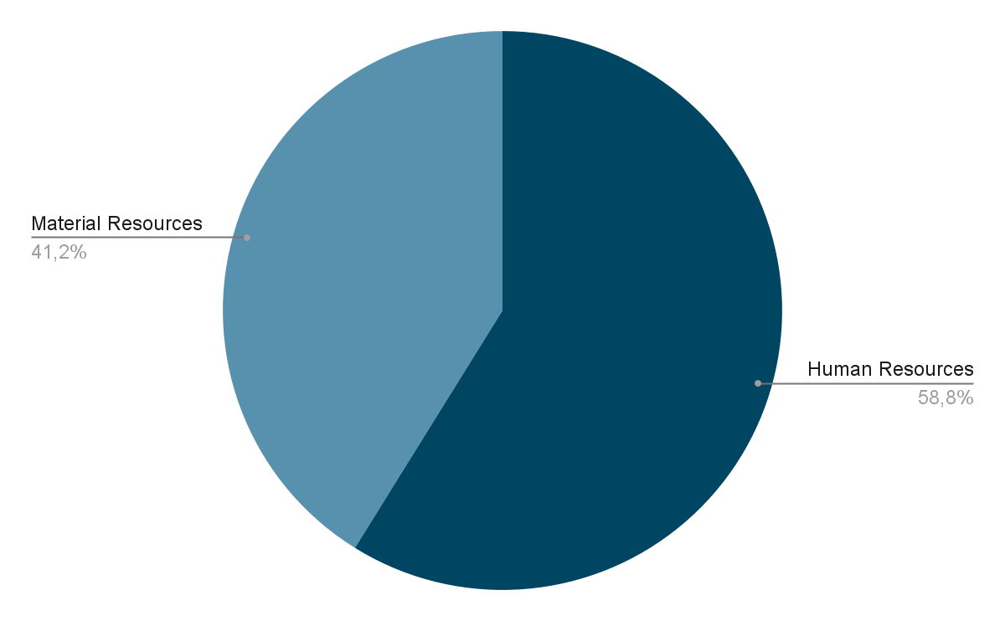

Graph 4: Cost Distribution.

1. **Resource Overview**

The general overview of resources, presented in Graph 5, outlines various parameters for each team member, including actual and remaining hours, the percentage of work completed, elaborated in Graph 6.

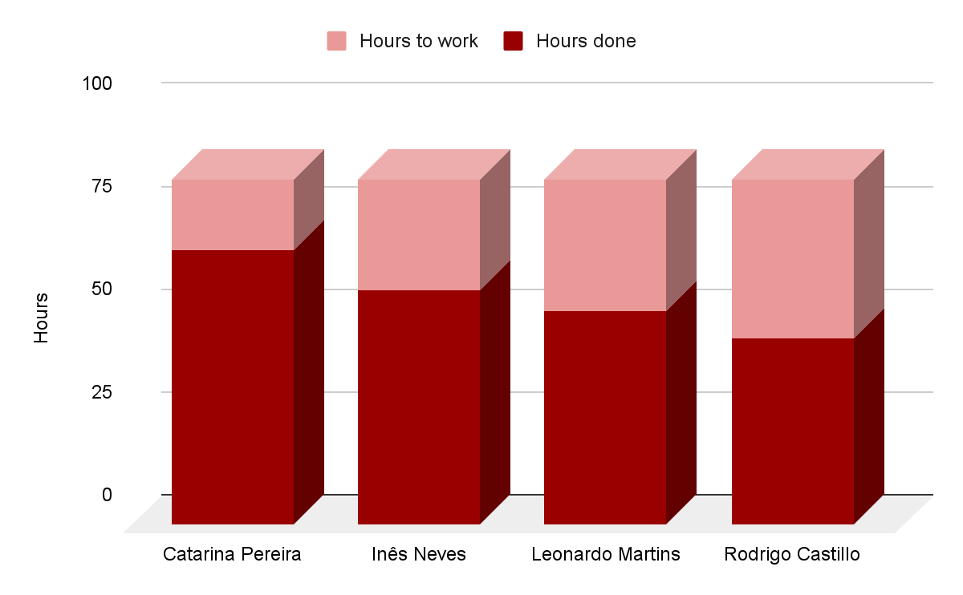

Graph 5: Resource Statistics.

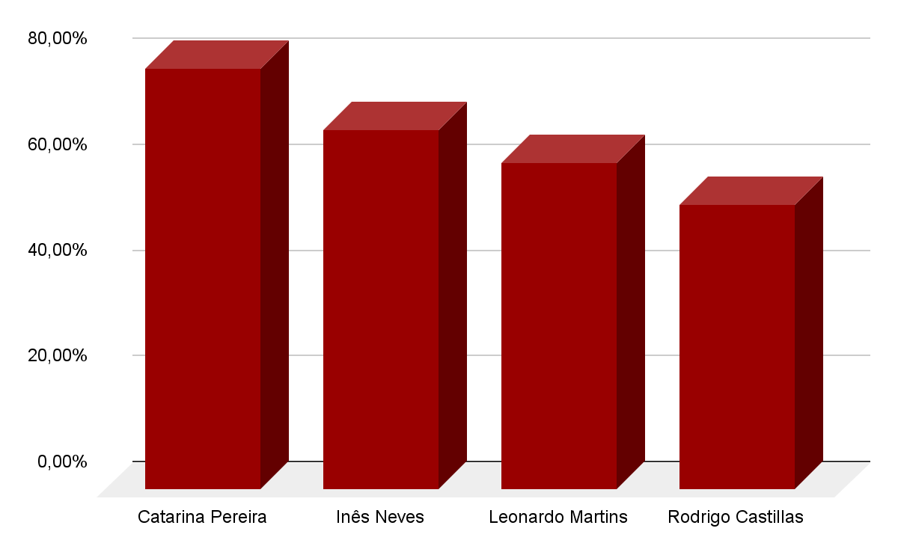

Graph 6: Labour Status.

1. **Task Cost Overview**

Graph 7 presents a comprehensive overview of task costs, providing a visual representation of both the actual and remaining expenses for each project phase.

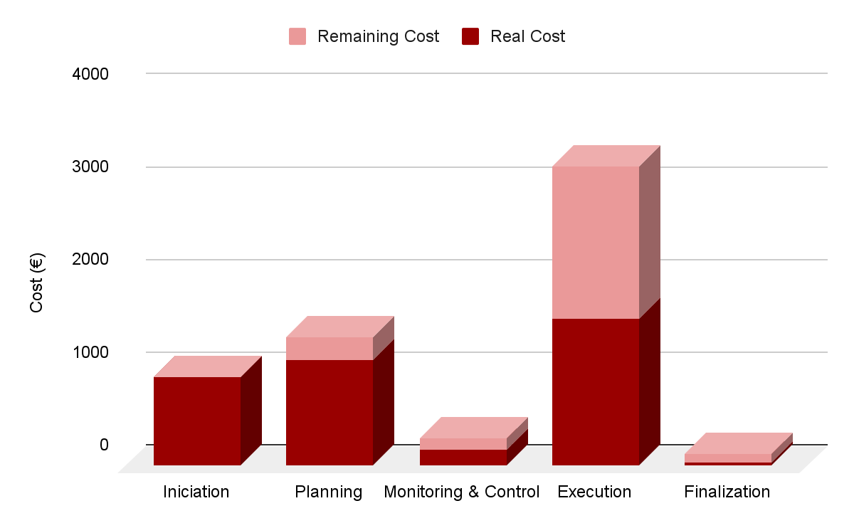

Graph 7: Cost Study.

Graph 8 illustrates the distribution of costs categorized by task status. It delineates expenses into three distinct categories:

1. Completed tasks (100% progress)
2. In-progress tasks (1% - 99% completion)
3. Not initiated tasks (0% progress)

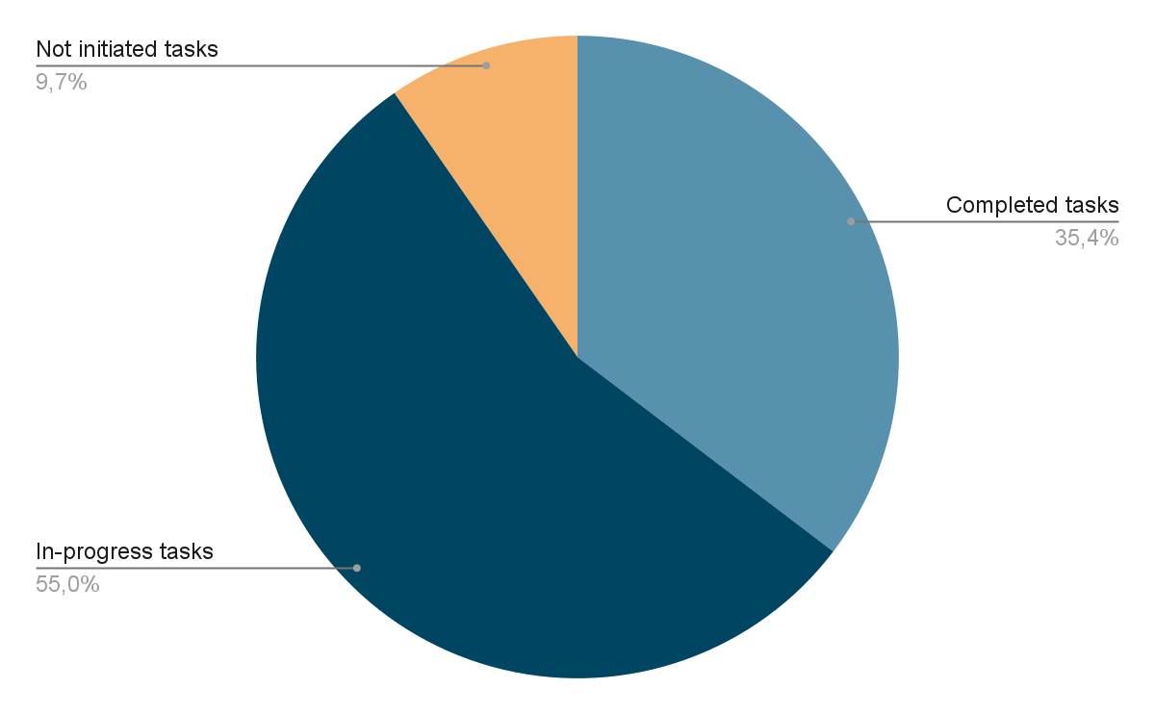

Graph 8: Cost Distribution.

# Project Overview

To summarize, so far the work team has been able to derive values for Table 3.

| Table 3: Project Overview. | |
| --- | --- |
| **Indicator** | **Value** |
| Total Project Duration | 14 weeks |
| Current Project Duration | 10 weeks |
| Total Project Cost | 6007,75 € |
| AC (Actual Cost) | 3893,53 € |
| PV (Planned Value) | 3 744,78 € |
| EV (Earned Value) | 3905,04 € |
| CV (Cost Variance) | 11,51 € |
| SV (Schedule Variance) | 160,26 € |
| AV (Accounting Variance) | -148,75 € |
| SPI (Schedule performance Index) | 1,04 € |
| CPI (Cost Performance Index) | 1,00 € |

The project currently shows a minor accounting variance, with the actual value exceeding the planned value at the 10-week mark. However, both the cost variance and schedule variance are positive, indicating strong performance in terms of both cost and timeline. The Cost Performance Index (CPI) and Schedule Performance Index (SPI) are both at or above 1, reflecting that the project is progressing as planned, with efficient cost management and timely completion.

1. Risks

Effective risk analysis is a critical aspect of project development. Identifying and managing potential risks allows the team to proactively address issues that could impede the project's progress, Table 4.

Each risk is assessed for its likelihood of occurrence (O), impact (I), seriousness (S) and its impacts/effects. Mitigation actions are also provided to deal with these risks and minimize their impacts. Each of the items, for probability and impact, is given a score on a scale of 1 to 5, where 1 corresponds to low and 5 corresponds to high. The seriousness of each risk is obtained by multiplying the probability by the impact, making it possible to emphasize the risks that could have the greatest impact on the project if they occur, so as to be more attentive to them.

Risk management is an essential part of project planning, as it helps to prevent problems and keep the project on track. Therefore, identifying and assessing these risks is crucial to the success of the project.

| Table 4: Project Risks. | | | | | | |
| --- | --- | --- | --- | --- | --- | --- |
| **ID** | **Description** | **Mitigation Plan** | **I** | **O** | **S** | **Potential Impact** |
| 1 | Loss of a team member | Ensure clear communication, strong team organization, and ongoing motivation | 5 | 1 | 5 | Overload of working hours by other team members |
| 2 | Loss of customer confidence | Maintain regular communication with the client, keeping them informed | 5 | 2 | 10 | Risk of project misalignment or failure |
| 3 | Exceeding the stipulated budget | Continuously assess time allocations for each task to control costs | 3 | 5 | 15 | Potential failure in project management review |
| 4 | Delays in the delivery of milestones / deliverables | Monitor and control deadlines set in the Gantt chart for all activities | 2 | 5 | 10 | Delays could affect project final grade |

1. Success

This section will be described when the team is carrying out the final version of the work plan and assessing which success factors are relevant to the project.

1. Lessons Learned

This section will be described when the project is finalized.

# Declaration of Knowledge

The undersigned parties declare that they have read and fully understand the contents of this document. By signing it, they confirm that they are aware of all its terms, responsibilities and commitments, and assume the fulfillment of their duties as described in this document.

Date: ___________________

Team Leader

Sponsor